**ACAT Feasibility Report**

**DOCUMENT CONTROL:**

1. **INTRODUCTION**
2. **REQUIREMENTS**
3. **SIMILAR SOLUTIONS & COMPARISONS**
4. **RISKS & COSTS ESTIMATES**
5. **CONCLUSION**
6. **INTRODUCTION**

Purpose: The purpose of this feasibility report is to outline the function, purpose, requirements, method of creation, and risks and costs of the ABET Course Assessment Tool (ACAT). This document will also attempt to defend the idea that the project described here is both viable and acceptable according to the requirements set forth by the client.

Project Team: Our team is supervised by Dr. Andrew Allen and our client is Dr. Prapita De. The below table lists the members of the project team along with each member’s university email.

|  |  |
| --- | --- |
| Member | Email |
| Joel Snider | js13623@georigasouthern.edu |
| Stephan Maxi | sm08333@georigasouthern.edu |
| Wyatt Landers | wl00951@georgiasouthern.edu |
| Patrick Evans | pe00461@georgiasouthern.edu |
| Jorge Ruiz | jr07471@georgiasouthern.edu |
| Langdon Boxxe | db04511@georgiasouthern.edu |

Project Description: The project itself is based heavily on the thesis published from the University of Reno Nevada titled “ACAT: ABET Course Assessment Tool” by Eugene O. Essa. This thesis outlines a web-based application that allows the user to enter a variety of data and information about a certain course, including assignment information, student information, and individual grades. The purpose of the tool is to simplify the process of creating assessment reports in order to maintain ABET accreditation.

Functionality: This tool will be designed with simple usability in mind. We plan to allow the user a variety of options on how to input course data, whether that be manually, or via spreadsheet style files, such as .xlsx or .csv, or via .pdf files. Our user interface will be intuitive and simple to navigate in order to allow usability from anyone.

1. **REQUIREMENTS**

Technical: The previously mentioned thesis outlines in Chapter 4 a list of 63 functional requirements the ACAT system must have. As we aim to use the outline given in this thesis as the basis for our project, we also have made it our goal to satisfy these requirements. The tables containing these 63 requirements are given below.

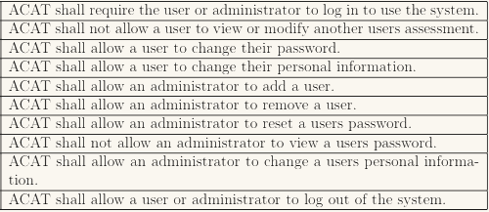

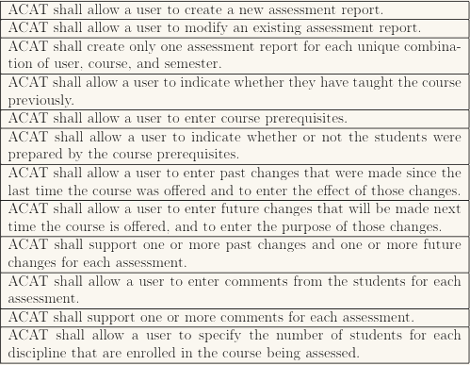

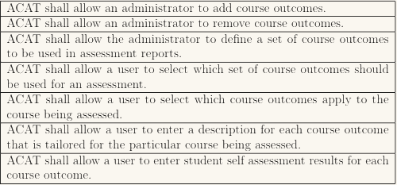

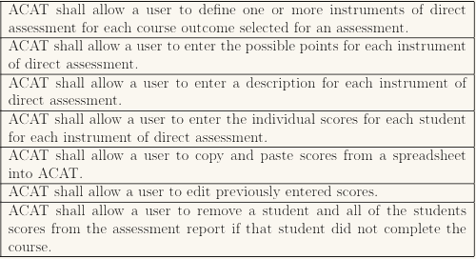

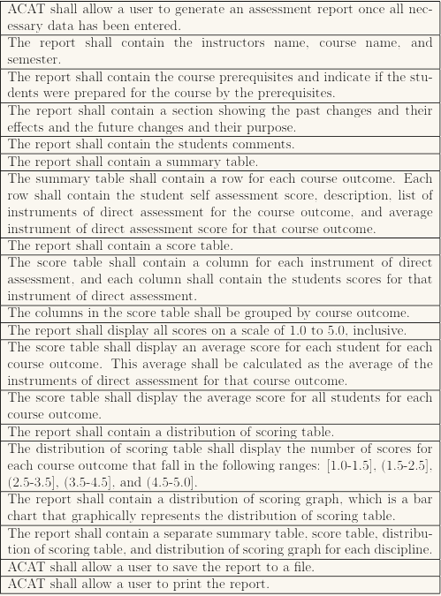

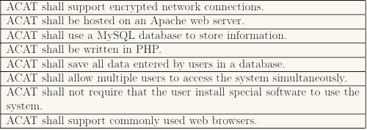

1. **SIMILAR SYSTEMS & COMPARISONS**

The University of Reno, Nevada uses ACAT software most similar to the one we are attempting to create. The primary differences between our proposed system and theirs is that our will allow for a variety of input and allow for individual weights of each assignment in the creation of course reports for accreditation purposes. Our system also allows the user to pull random samples from the lowest, highest, and middle thirds of grade ranges for each course or each assignment.

1. **RISKS & COSTS ESTIMATES**

Risks: With our system being web-based and making use of a database containing personal information of potentially thousands of student and university faculty members, data security is the greatest risk to our project. We aim to ensure that all access to contained data is encrypted using RSA encryption and to make sure that our website is secure from query injection methods in any of the input fields that the user has access to.

Costs: Since this project is being conducted fully by senior-level college students who work for free in order to receive a passing grade, our total cost estimate comes out to $0.00.

1. **CONCLUSION**

Our project team believes this undertaking to be extremely time consuming, but ultimately we look forward to the opportunity to familiarize ourselves with new teamwork methods and technologies. We are confident that when we finish with this project, we will be able to look back with pride in the work we have done.